PRACTICAL 5

**A )Create an html page with fields, eno, name, age, desg, salary. Now on submit this data to a JSP page which will update the employee table of database with matching eno**

**STEP 1 STEP 1 : COMPLATE THE DATA BASE PART >> GO TO SERVICE >>>>**

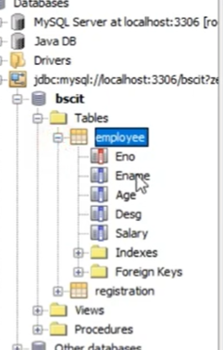

**STEP 2 : CLICK ON DATA BASE >>>>> RIGHT CLICK ON MY SQL >>> CREATE NEW DATA BASE >>>name>>> BSCIT**

**STEP 3 : RIGHT CLICK ON BSC IT AND CLICK ON CONNECT**

**STEP 4 : RIGHT ClLICK ON BSC IT >>> CREATE TABLE >> NAME > TABLE NAME IS :Ragistration >>**

**ADD COLUMN AS PER THE QUESTION AND SELECT TYPE ,SIZE**

**COLUMN SUCH AS emp no , emp name ,age ,….**

**STEP 4 : GO TO PROJECT >>> CREATE PROJECT >>>> JAVA WEB >>>>WEB APPLICATION >>> FINISHED**

**STEP 5 : PASTE BELOW CODE IN index.html in <body>**

**<form action="UpdateEmp.jsp" >**

**Enter Employee No. <input type="text" name="txtEno" ><br>**

**Enter Name<input type="text" name="txtName" ><br>**

**Enter age<input type="text" name="txtAge" ><br>**

**Enter Salary<input type="text" name="txtSal" ><br>**

**<input type="submit">**

**</form>**

**STEP 6: CREATE JSP PAGE**

**RIGHT CLICK ON WEB PAGES >>NEW >> JSP > NAME>JSP**

**COPY THE BODY OBJECT BELOW AND PASTE BETWEEN <BODY> </BODY>**

**<%@page contentType="text/html" import="java.sql.*" %>**

<html>

<body>

**<%**

**String eno=request.getParameter("txtEno");**

**String name=request.getParameter("txtName");**

**String age = request.getParameter("txtAge");**

**String sal = request.getParameter("txtSal");**

**try**

**{**

**Class.forName("com.mysql.jdbc.Driver");**

**Connection con = DriverManager.getConnection("jdbc:mysql://localhost:3306/LoginDB", "root", "root");**

**PreparedStatement stmt = con.prepareStatement("select * from emp where empid=?");**

**stmt.setString(1, eno);**

**ResultSet rs = stmt.executeQuery();**

**if(rs.next())**

**{**

**out.println("~~~ Employee Exist ~~~ ");**

**PreparedStatement pst1= con.prepareStatement("update emp set salary=? where empid=?");**

**PreparedStatement pst2= con.prepareStatement("update emp set age=? where empid=?");**

**pst1.setString(1, sal);**

**pst1.setString(2, eno);**

**pst2.setString(1, age);**

**pst2.setString(2, eno);**

**pst1.executeUpdate();**

**pst2.executeUpdate();**

**out.println("~~~ Record updates successfully ~~~ ");**

**}**

**else**

**{**

**out.println("Employee record doesnot exist !!");**

**}**

**}catch(Exception e)**

**{**

**out.println(e);**

**}**

**%>**

</body></html>

**OUTPUT**

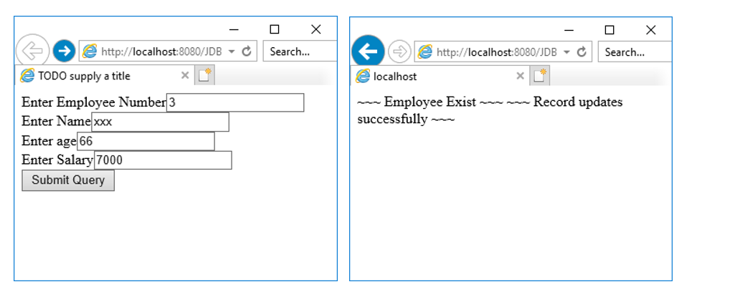

**YOUTUBE LINK:** [**https://www.youtube.com/watch?v=bf5agRnmJ4Q&list=PLf2Wj8X3RbBS8IbrmdbSTRNDKauvsVZsh&index=11**](https://www.youtube.com/watch?v=bf5agRnmJ4Q&list=PLf2Wj8X3RbBS8IbrmdbSTRNDKauvsVZsh&index=11)

**B) Create a JSP application to demonstrate the use of Expression Language**

**STEP 1: CREATE JSP PAGE**

**RIGHT CLICK ON WEB PAGES >>NEW >> JSP > NAME> Index.jsp**

**COPY THE BODY OBJECT BELOW AND PASTE BETWEEN <BODY> </BODY>**

<body>

**<%**

**application.setAttribute("author", "Richard Blum");**

**application.setAttribute("book", "Hardy Boys");**

**%>**

**<a href="Display.jsp">Click Here For Author Details</a>**

**<form action="Expression.jsp">**

**Student Name: <input type="text" name="sname" /><br>**

**Student Roll Num:<input type="text" name="rollno" /><br>**

**<input type="submit" value="Submit Details!!"/>**

**</form>**

</body>

**STEP 2 : CREATE ANOTHER JSP**

**RIGHT CLICK ON WEB PAGES >>NEW >> JSP > NAME> Display.jsp**

**COPY THE BODY OBJECT BELOW AND PASTE BETWEEN <BODY> </BODY>**

<body>

**<h3>AUTHOR DETAILS</h3>**

**<b>Author name</b> <br>**

**${applicationScope.author}<br>**

**<b>Book name</b> <br>**

**${applicationScope.book}**

</body>

**STEP 3 : CREATE ANOTHER JSP**

**RIGHT CLICK ON WEB PAGES >>NEW >> JSP > NAME> Expression.jsp**

**COPY THE BODY OBJECT BELOW AND PASTE BETWEEN <BODY> </BODY>**

<body>

**<h4>Student Data</h4>**

**Student name is ${ param.sname } <br>**

**Student Roll No is ${ param.rollno } <br>**

**<h4>Value Expressions</h4>**

**<b> Is 1 less than 2 ? </b> ${1<2} <br>**

**<b>Arithmetic expression 1+2+3 is </b> ${1+2+3}**

</body>

**OUTPUT**

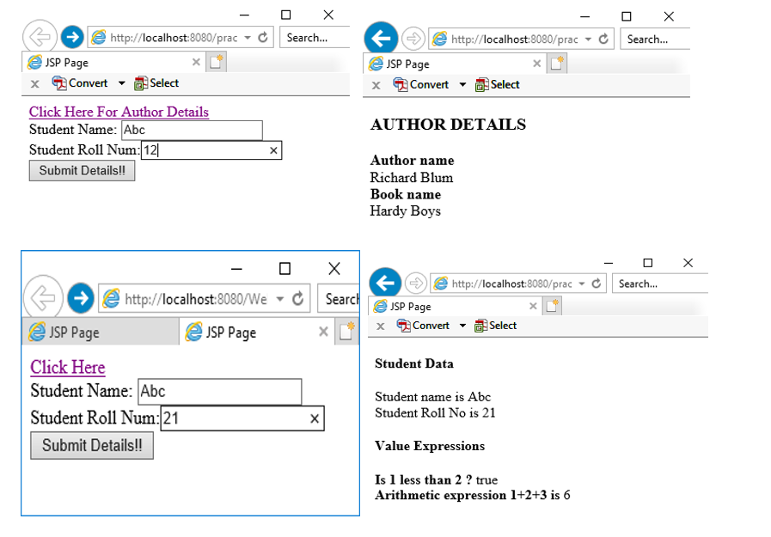

**YOUTUBE LINK :** [**https://www.youtube.com/watch?v=6msm0lQ9aaw&list=PLf2Wj8X3RbBS8IbrmdbSTRNDKauvsVZsh&index=12**](https://www.youtube.com/watch?v=6msm0lQ9aaw&list=PLf2Wj8X3RbBS8IbrmdbSTRNDKauvsVZsh&index=12)